**DETECTING PARKINSON'S DISEASE**

**USING WATSON MACHINE LEARNING**

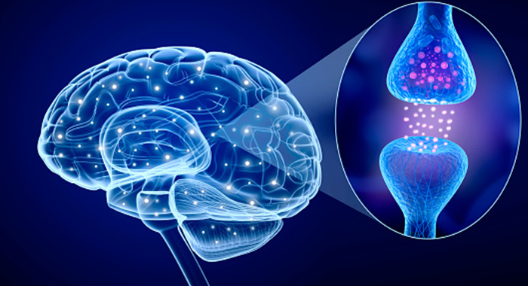

**INDEX**

1.INTRODUCTION

1. OVERVIEW
2. PURPOSE

2.LITERATURE SURVEY

1. Existing Problem
2. Proposed solution

3.THEORITICAL ANALYISIS

1. Block Diagram
2. Hardware/Software Designing

4.EXPERIMENTAL INVESTIGATION

5.FLOWCHART

6.RESULT

7.ADVANTAGES AND DISADVANTAGES

8.APPLICATIONS

9.CONCLUSION

10.FUTURE SCOPE

**INTRODUCTION TO PROJECT**

More than 10 million people are living with Parkinson’s Disease worldwide, according to the Parkinson’s Foundation. While Parkinson’s cannot be cured, early detection along with proper medication can significantly improve symptoms and quality of life.

The researchers found that the drawing speed was slower and the pen pressure is lower among Parkinson’s patients. One of the indications of Parkinson’s is tremors and rigidity in the muscles, making it difficult to draw smooth spirals and waves. It is possible to detect Parkinson’s disease using the drawings alone instead of measuring the speed and pressure of the pen on paper. Our goal is to quantify the visual appearance(using HOG method) of these drawings and then train a machine learning model to classify them. In this project, We are using, Histogram of Oriented Gradients (HOG) image descriptor along with a Random Forest classifier to automatically detect Parkinson’s disease in hand-drawn images of spirals and waves.

**LITERATURE SURVEY**

Parkinson’s disease (PD) is a chronic, degenerative neurological disorder that affects as many as one in a 100 people over the age of 60. It is estimated that more than five million individuals have PD worldwide, and the number is growing with today’s aging population.

While primarily characterized by motor disturbances — including involuntary tremors and impaired movement — it is not uncommon for PD patients to also experience cognitive declines, behavioral issues, and sleep disorders.

The Michael J. Fox Foundation for Parkinson’s Research has provided a grant to IBM to try to better understand PD and the route it can take in patients, with the goal of paving the way for more effective treatments. Through this partnership, The Michael J. Fox Foundation is making available its data from the Parkinson’s Progression Markers Initiative (PPMI), an observational study that has collected a vast amount of anonymous longitudinal data across cohorts of PD patients.

This is IBM’s next step in our quest to better comprehend and track neurological conditions such as PD. A few weeks ago, we announced a new fingernail sensor prototype , which could one day help clinicians to continuously track, monitor and more accurately diagnose movement and neurodegenerative disorders with the help of data and AI.

**THEORITICAL ANALYSIS**

* User interacts with the UI (User Interface) to upload the image as input
* The uploaded image is analyzed by the model which is integrated
* Once the model analyses the uploaded image, the prediction is showcased on the UI and OpenCV window

To accomplish this, we have to complete all the activities and tasks listed below

* Data Collection
  + Collect the dataset or Create the dataset
* Image Preprocessing.
* Importing the required libraries
* Loading Train data and Test data
* Quantifying images
* Label Encoding
* Model Building
  + Training the model
  + Testing the model
  + Model Evaluation
  + Saving the model
* Application Building
  + Create an HTML file
  + Build Python Code

 Anaconda Navigator is a free and open-source distribution of the Python and R programming languages for data science and machine learning related applications. It can be installed on Windows, Linux, and macOS . Conda is an open-source, cross-platform,  package management system. Anaconda comes with so very nice tools like JupyterLab, Jupyter Notebook,

QtConsole, Spyder, Glueviz, Orange, Rstudio, Visual Studio Code. For this project, we will be using Jupyter notebook and Spyder

To install Anaconda navigator and to know how to use Jupyter Notebook & Spyder using Anaconda watch the video

**EXPERIMENTAL INVESTIGATION**  
  
These are brain-imaging scans and can tell your specialist what the structure of your brain looks like. Brain scans of people with **Parkinson's** usually look normal, but they can be helpful in diagnosing other types of parkinsonism – the scan may not look normal in some of the rarer forms.

Parkinson's disease (PD) was characterized by late-onset, progressive dopamine neuron loss and movement disorders. The progresses of PD affected the neural function and integrity. To date, most researches had largely addressed the dopamine replacement therapies, but the appearance of L-dopa-induced dyskinesia hampered the use of the drug. And the mechanism of PD is so complicated that it's hard to solve the problem by just add drugs. Researchers began to focus on the genetic underpinnings of Parkinson's disease, searching for new method that may affect the neurodegeneration processes in it. In this paper, we reviewed current delivery methods used in gene therapies for PD, we also summarized the primary target of the gene therapy in the treatment of PD, such like neurotrophic factor (for regeneration), the synthesis of neurotransmitter (for prolong the duration of L-dopa), and the potential proteins that might be a target to modulate via gene therapy. Finally, we discussed RNA interference therapies used in Parkinson's disease, it might act as a new class of drug. We mainly focus on the efficiency and tooling features of different gene therapies in the treatment of PD.

**FLOW CHART**

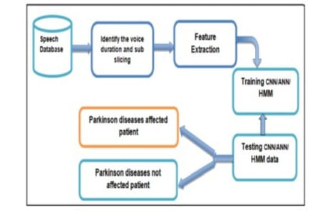

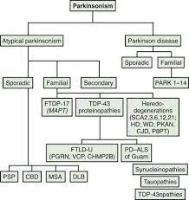

**RESULT**

*By the end of this project:*

* You’ll be able to understand the problem to classify if it is a regression or a classification kind of problem.
* You will be able to know how to pre-process the image by using different data pre-processing techniques.
* you will learn how to use OpenCV and machine learning to automatically detect Parkinson’s disease in hand-drawn images of spirals and waves
* You will be able to know how to find the accuracy of the model.
* You will be able to Build web applications using the Flask framework.

**ADVANTAGES AND DISADVANTAGES**

Advantages:

1. No infection risk associated with surgical thalamotomy or surgical implants
2. “Test” sonications to confirm precise targeting prior to full ablation
3. We can know whether a person is affected with the disease or not without going to the hospital.

Disadvantages:

1.For this we need internet connection.

2.FingerPrint is compulsory.

**APPLICATIONS**

1. Parkinsons disease is a major medical problem.

2. It can be cured if treated in the early stages.

3. Attributes of various medical tests are investigated to distinguish which

attributes may contain helpful information about the disease.

4.This IBM Watson Machine Learning model is applicable in the field of medical science.

Machine learning refers to a computer program, which calculates and

deduces the information related to the task and obtains the

characteristics of the corresponding pattern. This technology can

achieve accurate and economical diagnoses of diseases; hence, it might

be a promising method for detecting Parkinsons disease. It has become a new kind of medical tool with the development of information technology and has a broad application prospect because of the rapid development of

electronic health record.

**CONCLUSION AND FUTURE SCOPE**

After completing this, we can add more categories in this work, can make this more efficient. Using more classifiers on this dataset can get a better understanding on which classifier can be the best for this work.

**Output**:

Screen Shots

